Contents

Step1: set up a working server & sql 1

Step2: set up package structure 1

Step3: set up db to server connection 2

Step4: Create Employee JPA Entity & verify that hibernate auto creates the **employee** table in MySQL 3

Step5: Create EmployeeRepository Interface & Resource Not Found 4

Step5: Create & Test REST API Service [Save Employee] 5

Step6: Create & Test REST API Service [Get All Employees] 8

Step7: Create & Test REST API Service [Get Employee By Id] 11

Step8: Create & Test REST API Service [Update Employee] 13

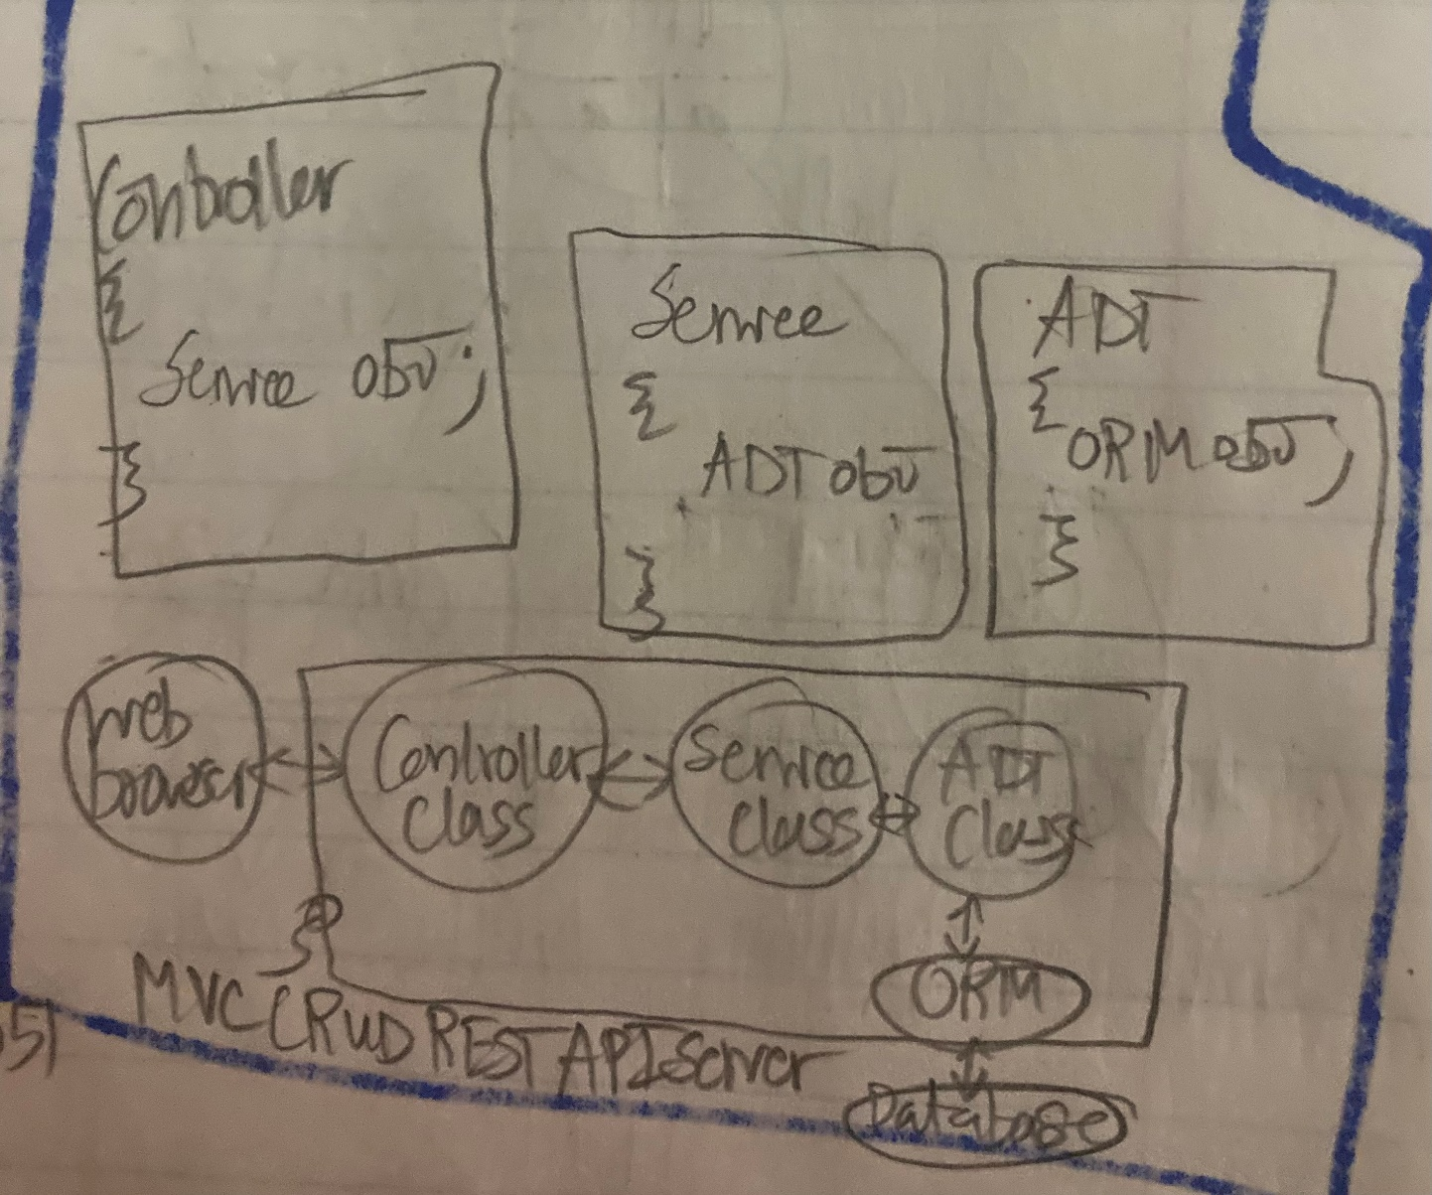

# Step1: set up a working server & sql



# 

# Step2: set up package structure

# Step3: set up db to server connection

# Step4: Create Employee JPA Entity & verify that hibernate auto creates the **employee** table in MySQL

# Step5: Create EmployeeRepository Interface & Resource Not Found

# Step5: Create & Test REST API Service [Save Employee]

id = autogenerated pk

# Step6: Create & Test REST API Service [Get All Employees]

# Step7: Create & Test REST API Service [Get Employee By Id]

# Step8: Create & Test REST API Service [Update Employee By Id]

# Step9: Create & Test REST API Service [Delete Employee By Id]

